RTL CHALLENGE

DAY-9:- Verilog Code for Implementation of FULL SUBTRACTOR using TWO Half
Subtractors & Four bit Full Subtractor.

Software used:- Xilinx Vivado(2023.1)
Theory:
Full Subtractor Using Two Half Subtractors:-

A Full Subtractor can also be implemented with two Half Subtractor and one OR gate, as shown in the Fig. 3.24. The difference output from the second Half Subtractor is the exclusive-OR of Bin and the output of the first Half Subtractor, which is same as difference output of Full Subtractor.
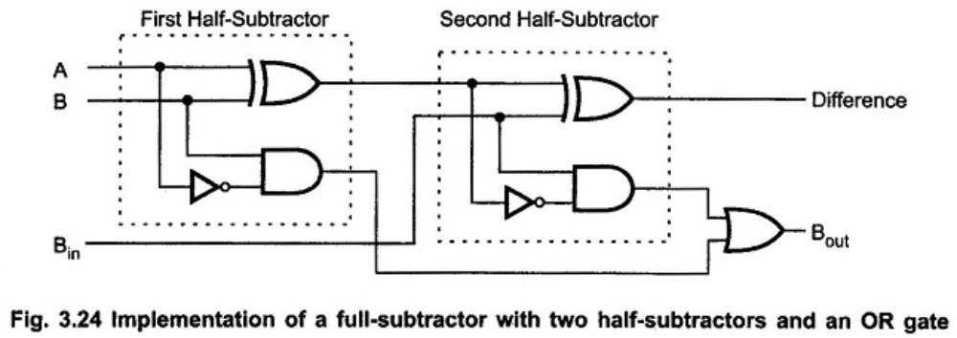

4-BIT Full Subtractor:
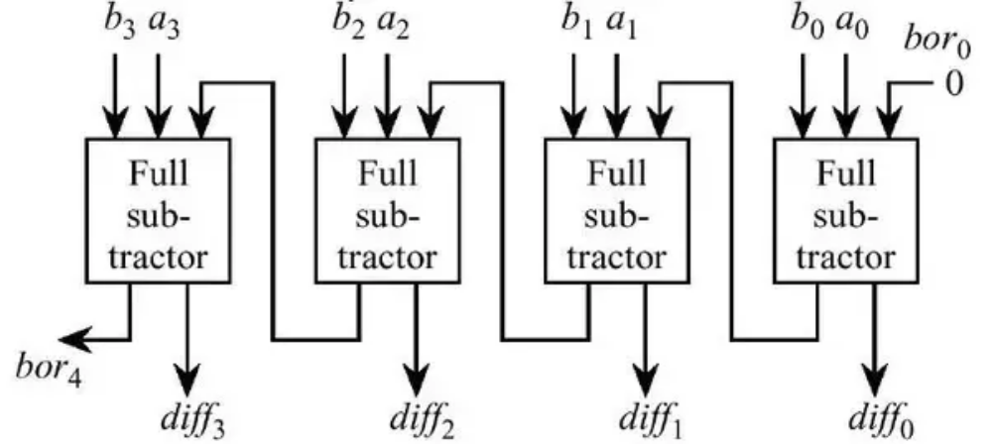

CODE FOR FULL SUBTRACTOR USING TWO HALF SUBTRACTORS:

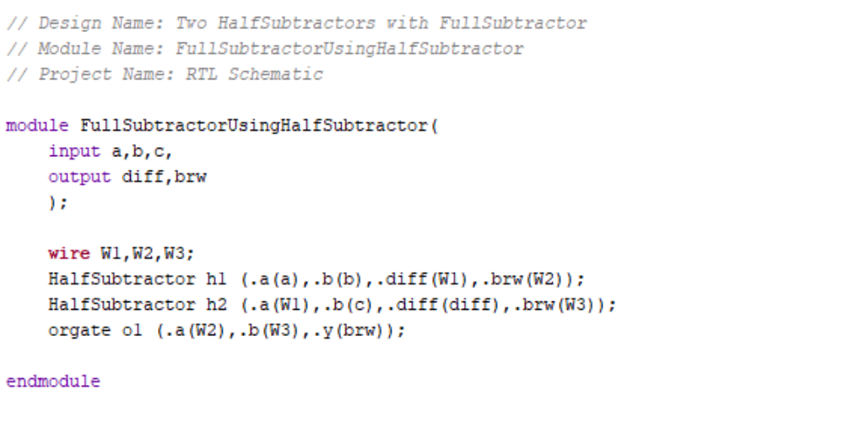
TEST BENCH:

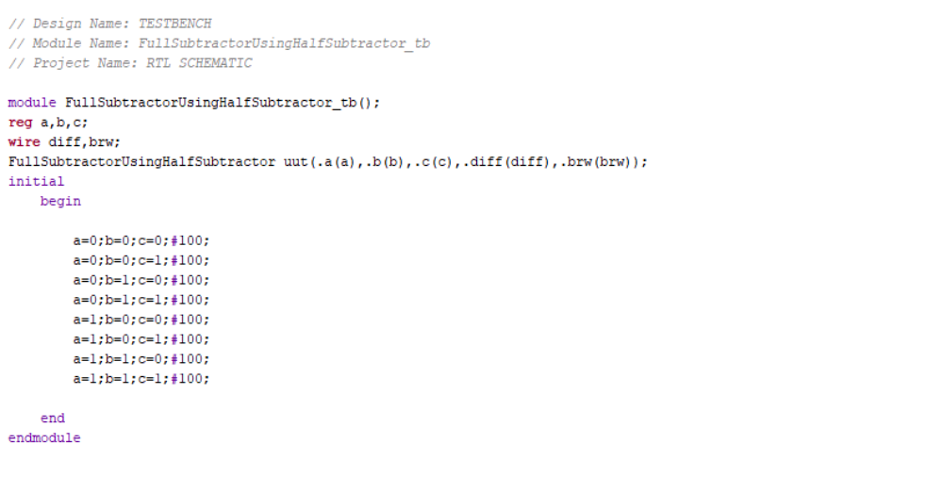

RTL SCHEMATIC:
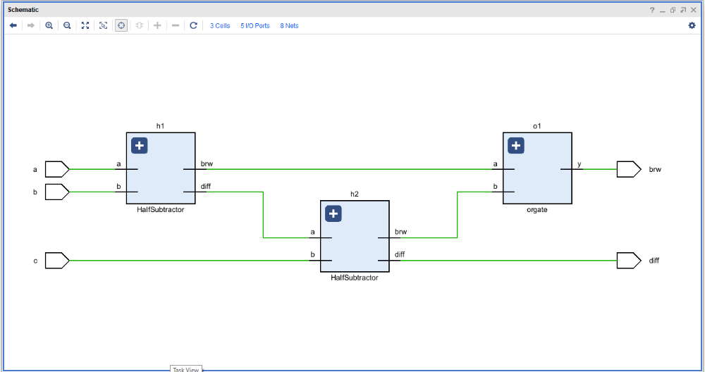

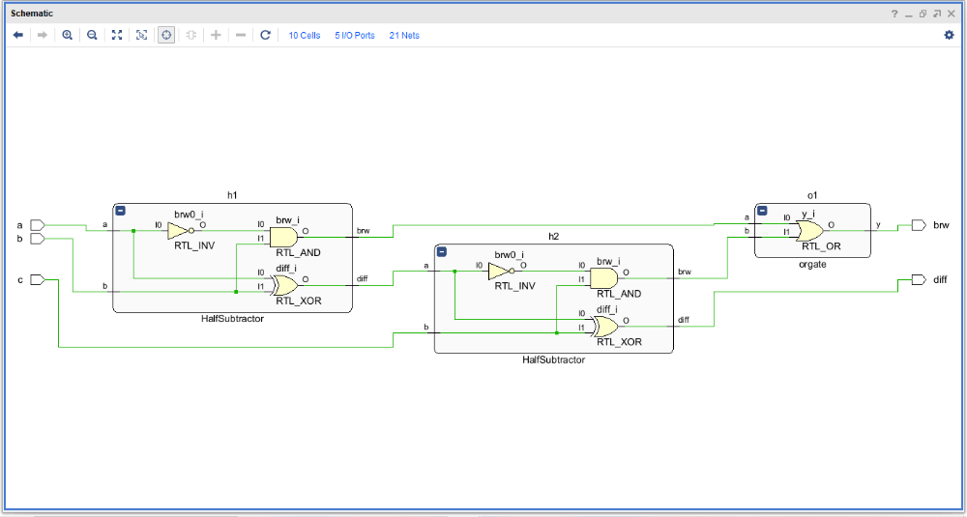

Four Bit Full Subtractor:

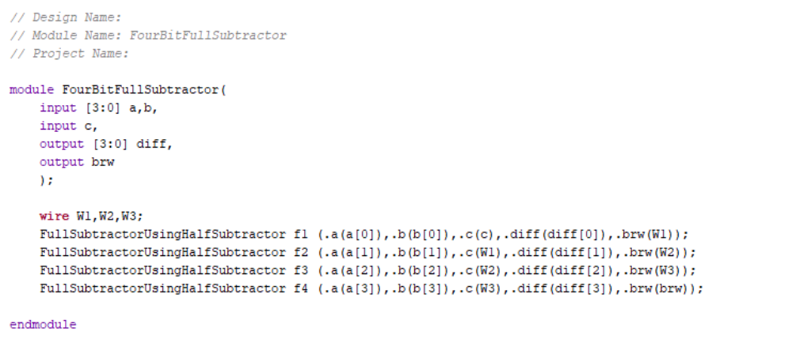

TEST BENCH:


RTL SCHEMATIC:

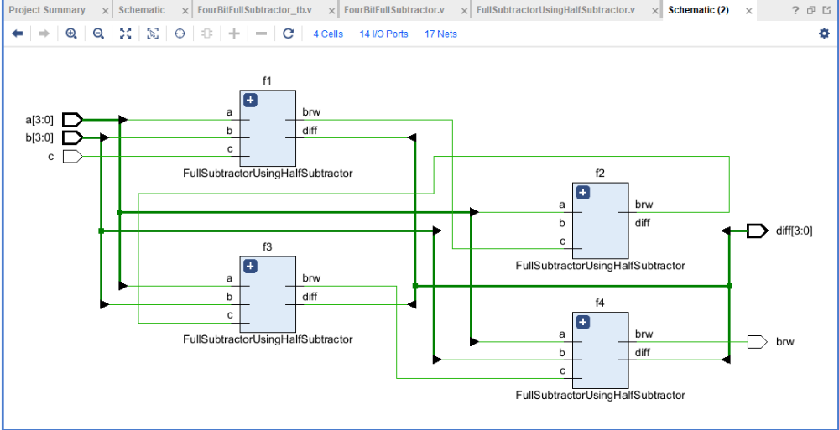

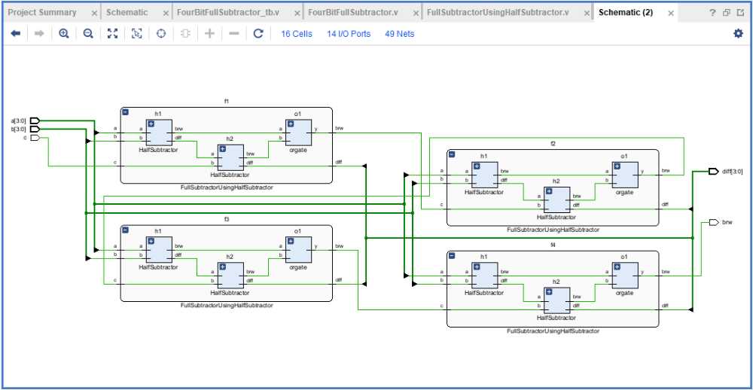

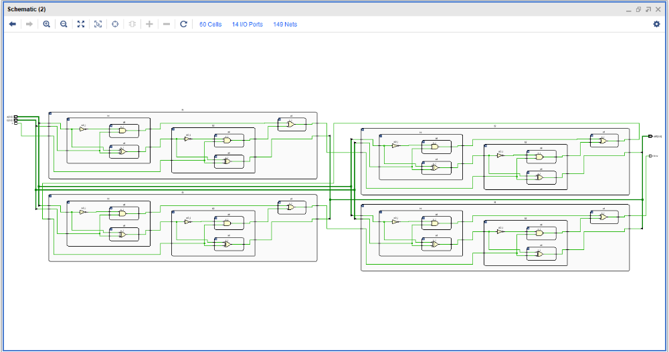

OUTPUT WAVE FORMS:

